**Calculate the number of employees corresponding to each skill from the table 'employee' which is loaded in the Demo.**

1. Creation of Database in Hive and creating a table inside the database.

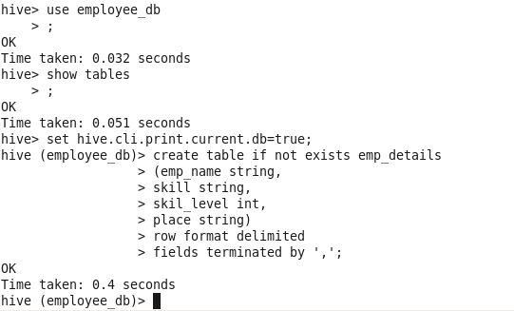

2. Loading the data into the table.

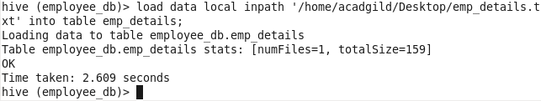

3. Displaying the contents of the table.

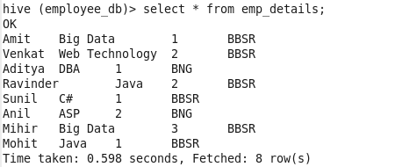

4. Calculating the number of employees corresponding to each skill from the table.

